# Guidance on WS85 firmware upgrade

**Prepare for upgrade:**

1. Install software “EcowittISPTool V1.0.0” on Windows PC
2. Firmware “WS85_Vx.x.x_APP.hex”
3. A USB to micro-USB type A **data cable** (not include in package)

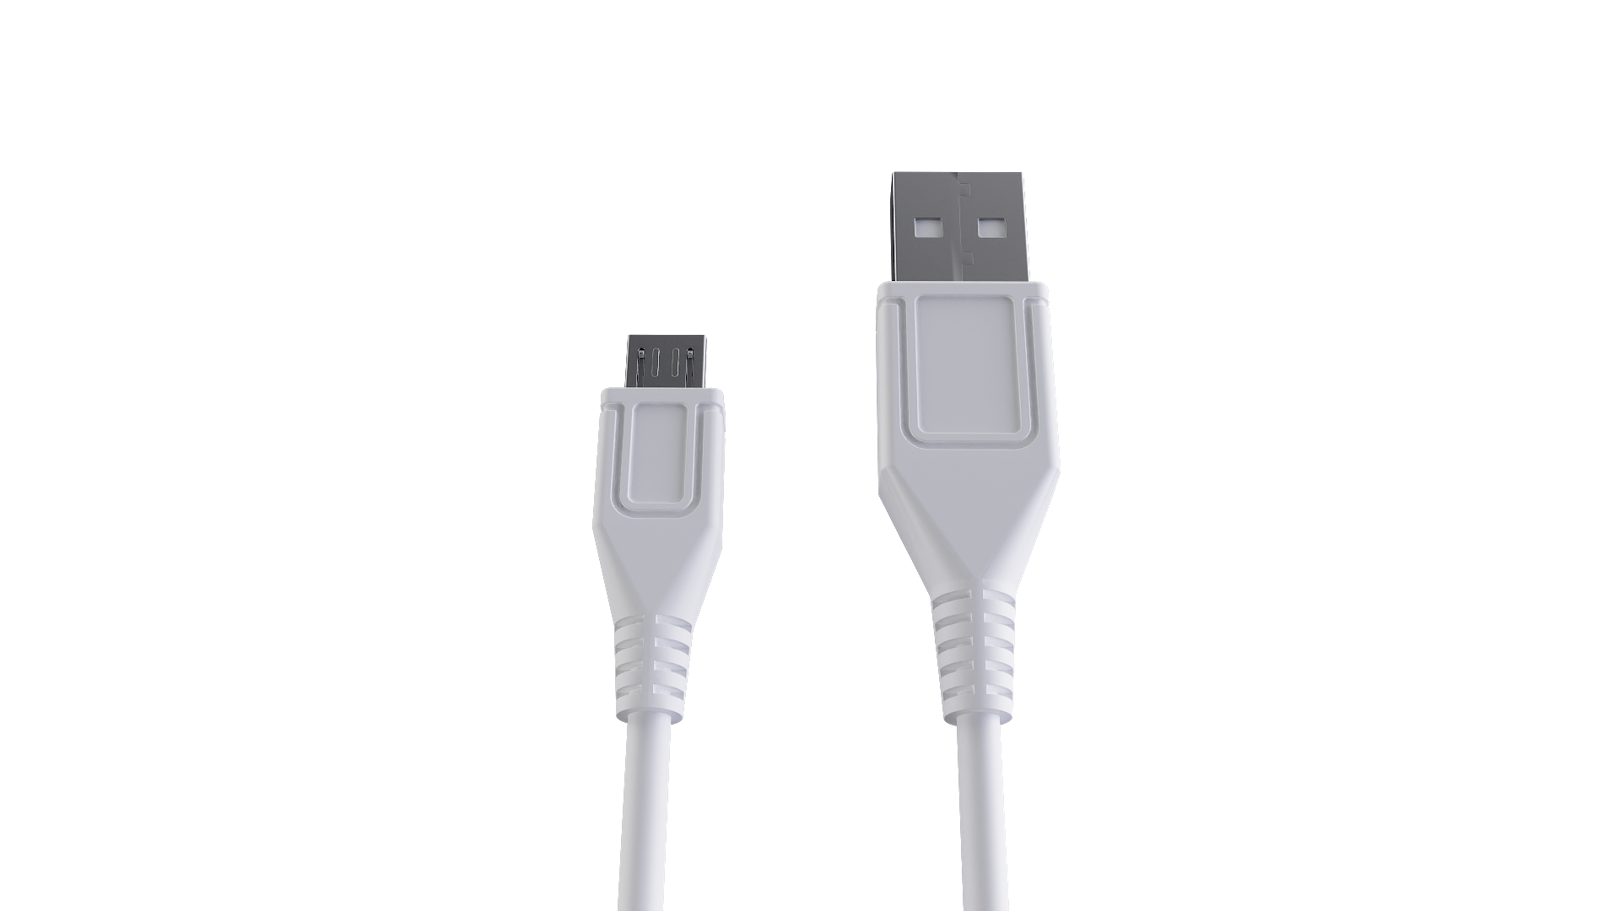

**Upgrade:**

1. Remove the white silicone sleeve from WS85

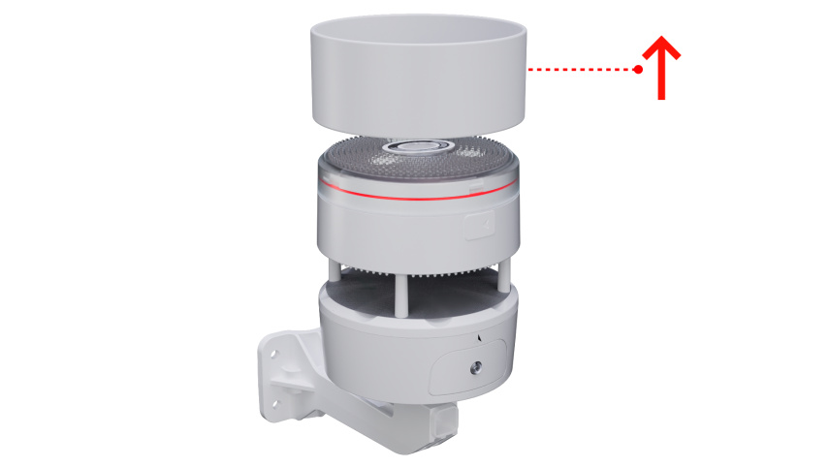

1. Use a USB data cable to connect the WS85 with the PC. (Note: Not every USB cable you use for charging is a data cable.)

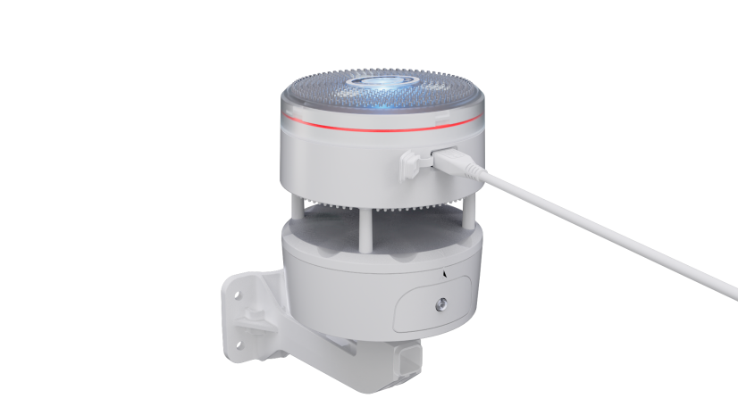

1. Press the ”RESET” button on WS85 to enter boot mode
2. The LED will flash quickly on the top of the WS85

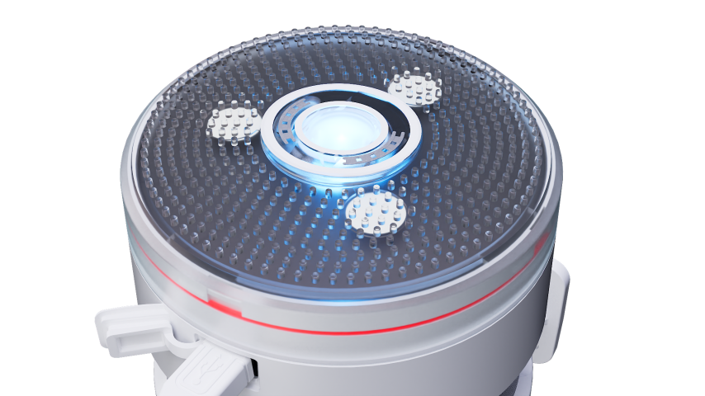

1. Double-click “EcowittISPTool V1.0.0(EN).exe” after unzipping the upgrade file

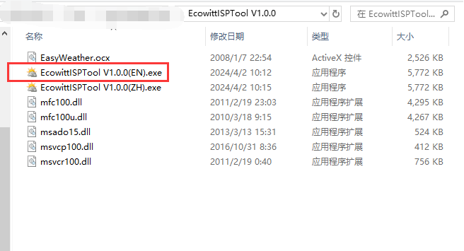

1. Click “Select” to add firmware

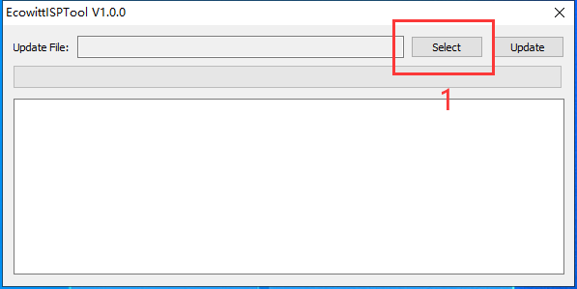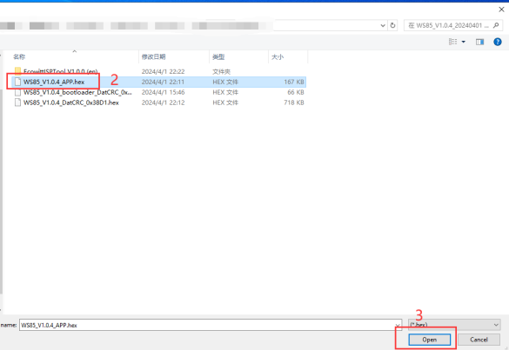

1. Choose the hex file and then click “open”
2. Click “Update”

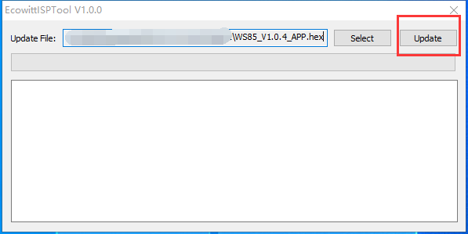

1. If it shows “Upgrade successful!”, then you have done well.

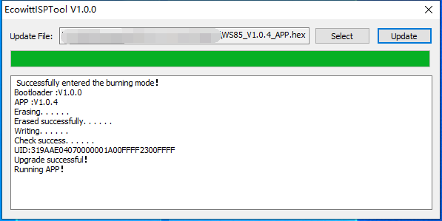

1. If it shows “failed” then please checking your operation, and then contact our support.

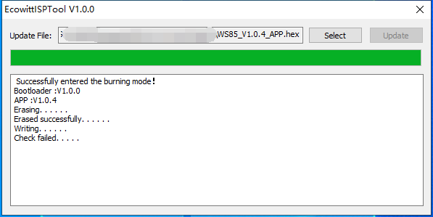

**Troubleshooting:**

In principle, it doesn't matter if the USB outlet you use on your computer is USB2.0 or USB3.0; USB ports, generally, can be "moody" pieces and be a nightmare. Sometimes, you have to reboot your computer first to get it to work electrically properly. Sometimes, a simple restart/reboot is not enough (warm restart), but you need a complete shutdown and a subsequent restart (cold restart) to get "the electricity" straight. Sometimes, you must change the USB port or computer before the connection gets adequately established.